**WEB DEVELOPMENT**

**PRACTICAL 13,14,15,16**

**Name:** Vrishav Garg

**Roll No.:** 12111051

**Branch:** CSE

**PRACTICAL 13:**

**CODE:**

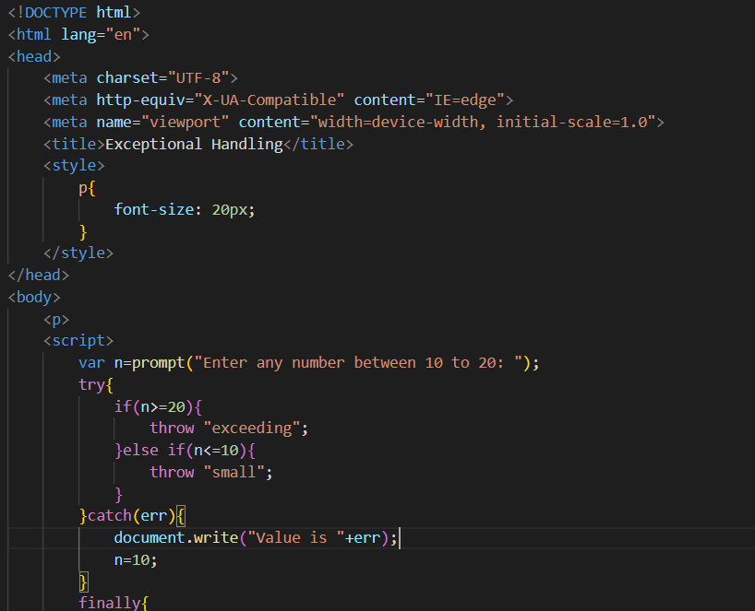

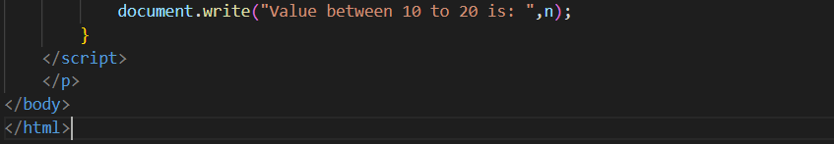

**Output:**

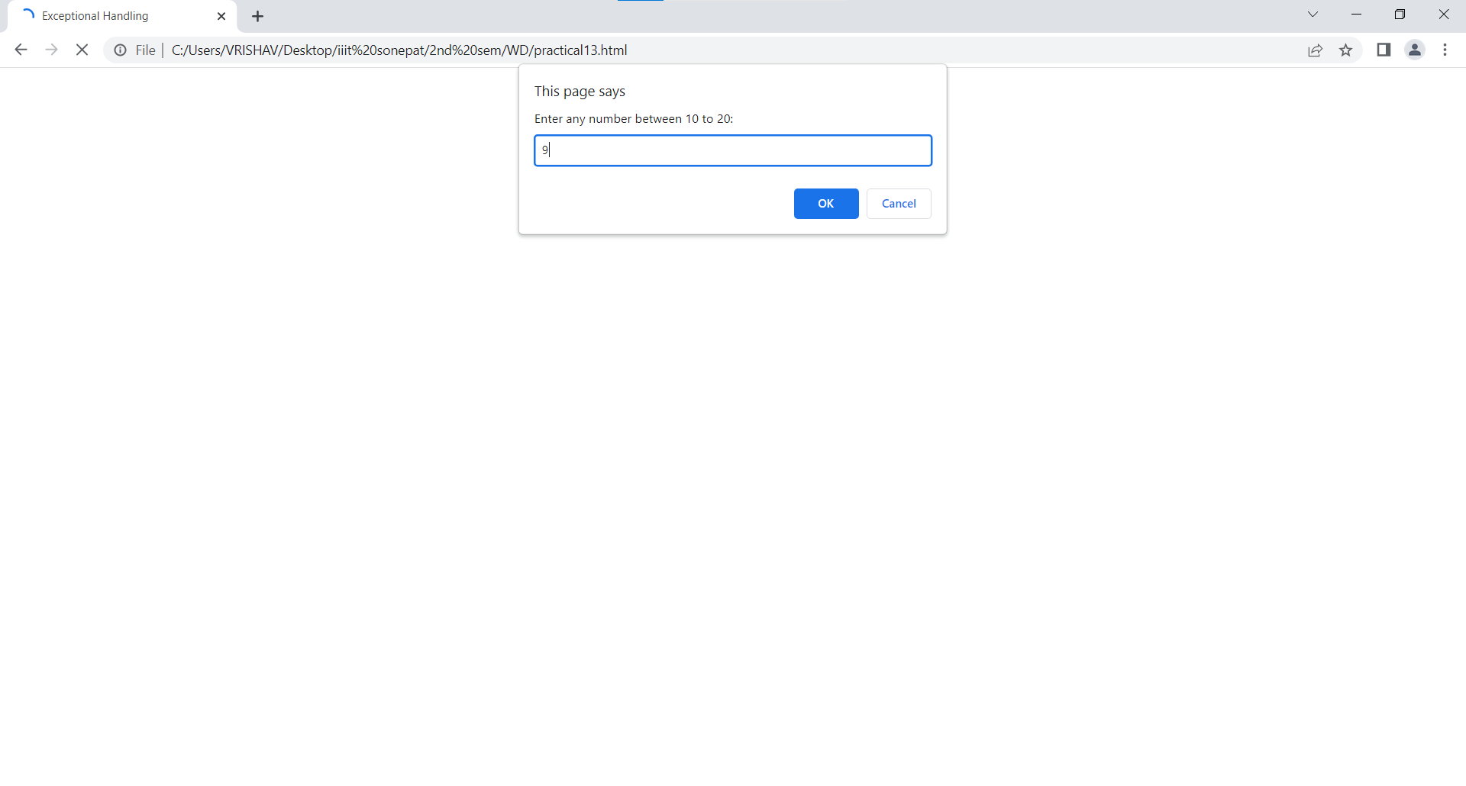

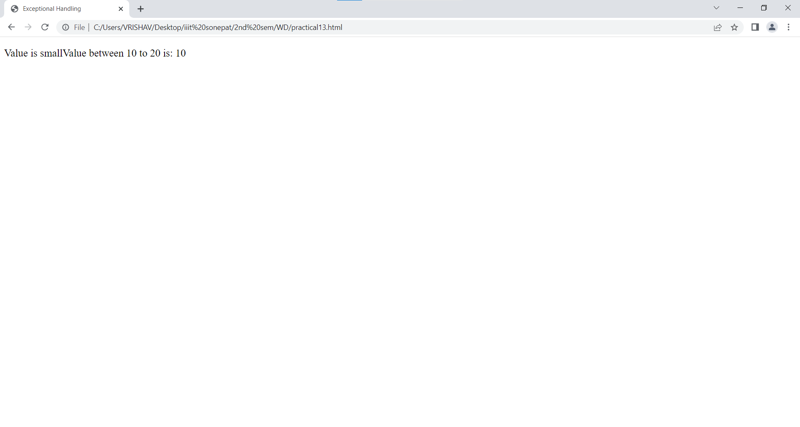

**Practical 14:**

**Code:**

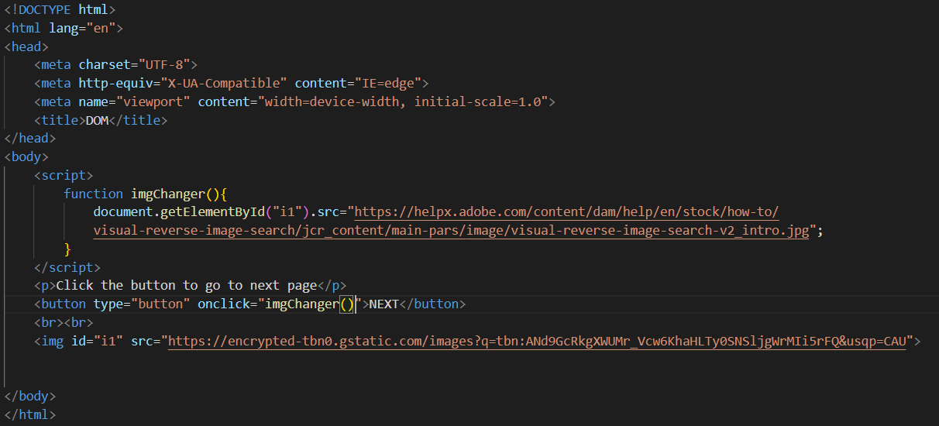

**Output:**

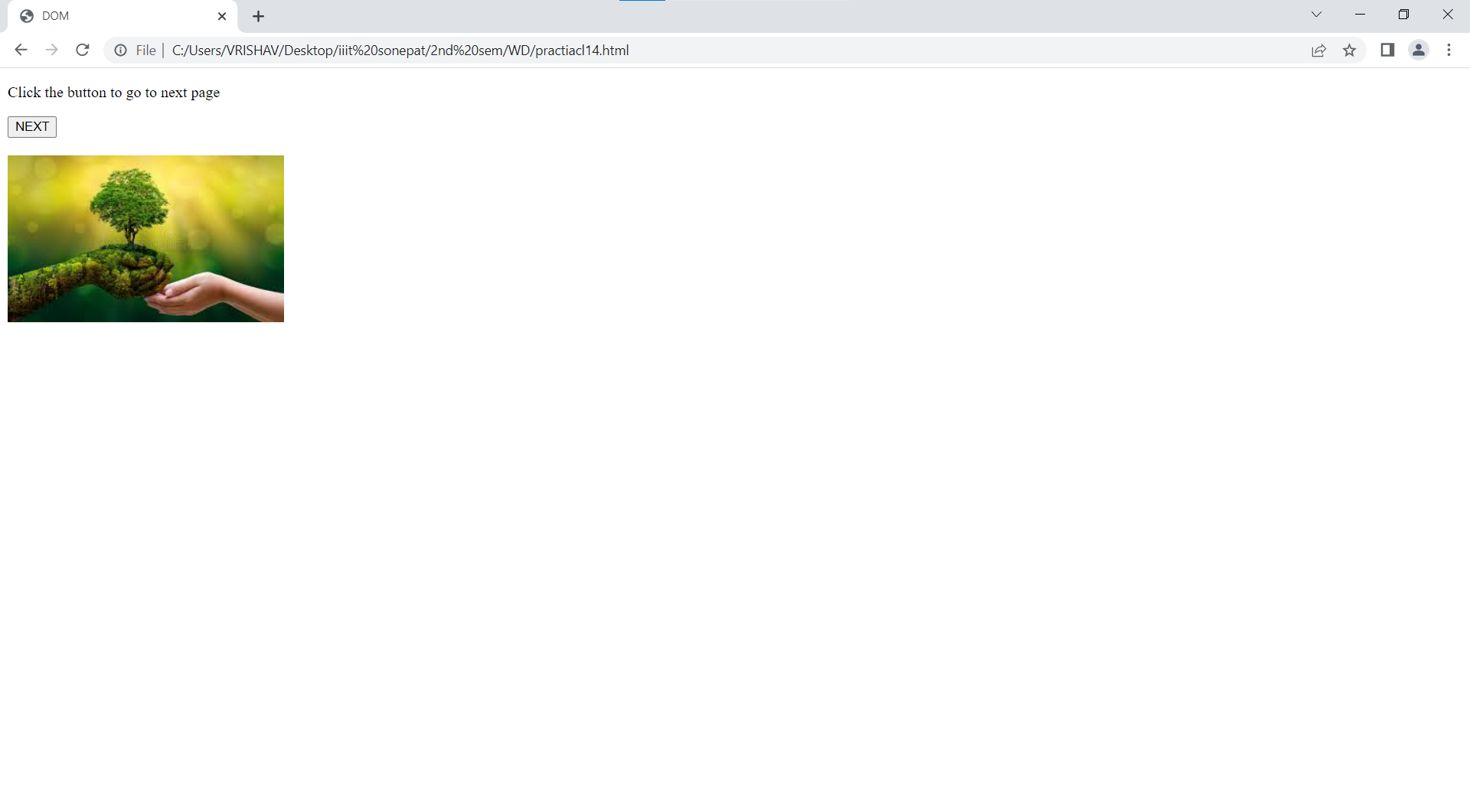

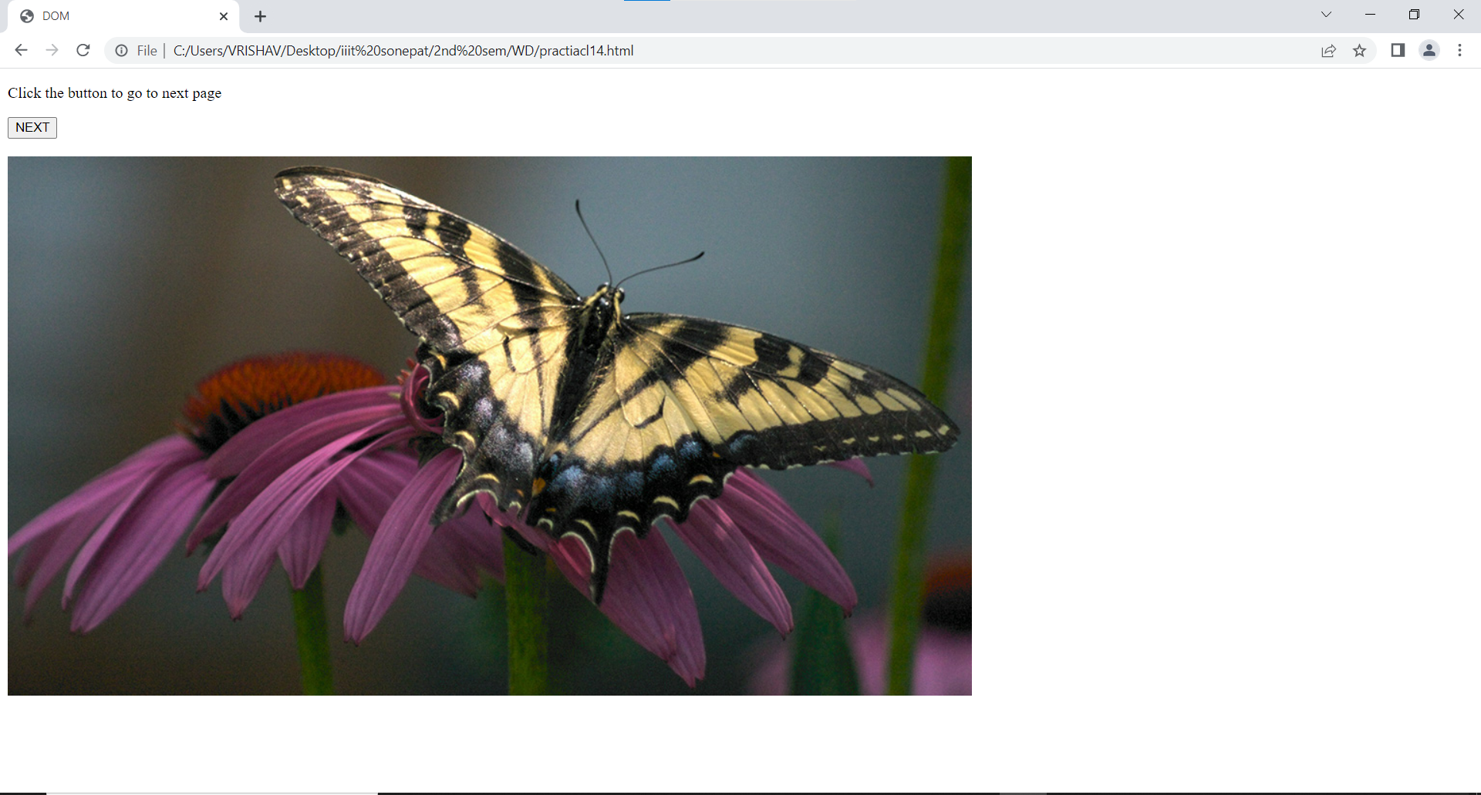

**Practical 15:**

**Code:**

**Output:**

